**inSight 2017**

**Department : Common to all departments**

**Problem Title : Notification generator.**

**Problem Code : PS03**

**Problem Description :**

The most important part of the student life is information. There are many information that the students don’t get to know about, it may be regarding the competitions, seminars or general notices from the department or any kind of circular and many more. An android application needs to be developed which would send notifications to all the registered students that the admin intends to send. **The admin must have a facility of creating a circular or notice by just sending an email to the application also, apart from him creating a notification on his version of the app.**

The application should also keep track of the people who have read the information that was sent. (something like blue ticks thing in whatsapp).

**Proposed solution:**

*We will build two apps(android).The* ***first*** *app will be the “principal” app and will have access to a server containing the database of all the students. This server will be maintained (maintenance, addition ,removal of data etc) by the college. The principal app will give the user (Principal ,HOD ,etc) the option to directly send a notification from the app ,by selecting the appropriate fields. Also the user can send an email to an email address assigned to the app, with the subject of the email containing the fields specifying the concerned branch, year etc and the body containing the required “notice” to be delivered. It will be sent to the server. The user access can be restricted by login-id and password*

*The* ***second*** *app will be a lightweight app that must be installed by the student(s).The student must specify their USN at the time of first use of the app. This app will generate a notification whenever it receives data from the server generated by the first app. When the user clicks(selects) on the notification, the second app will return a “read” result to the server. Also, if a date and/or time is also specified, the app will remind the student of the notice ,each day once till the date specified in the notice(if only date is mentioned).*

**Technology Stack :**

*Android Development : We will use android ide and API’s to develop the first and the second app.   
Since SQL support is built in android, the databases will be queried directly from the app.*

**Use Case:**

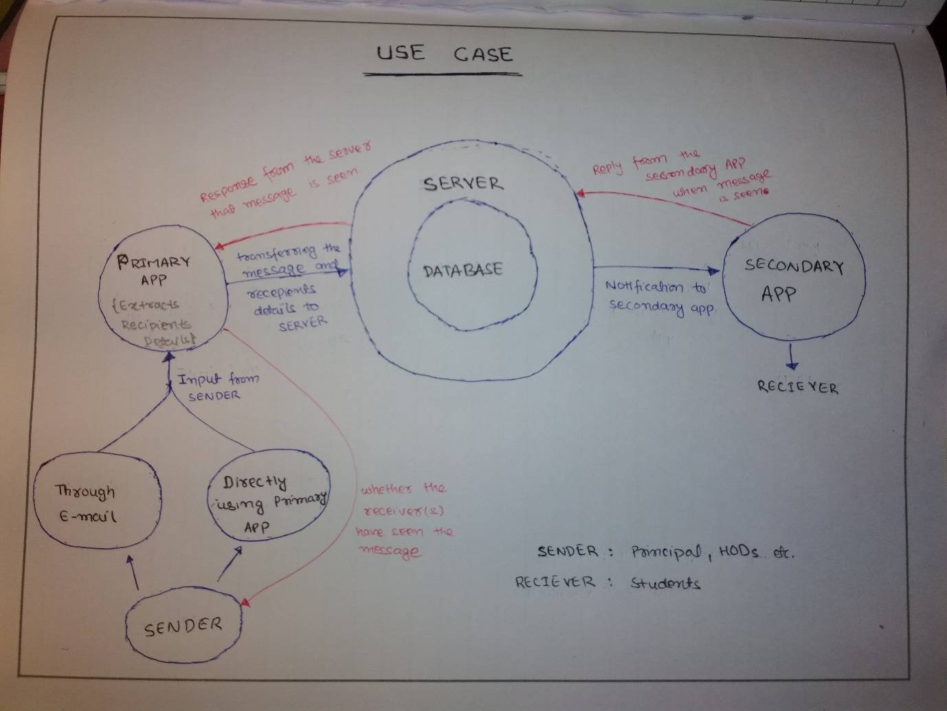

**Team Members details:**

|  |  |  |  |  |
| --- | --- | --- | --- | --- |
| **Role** | **Name** | **USN** | **Email id** | **Phone no.** |
| Team Leader | Ashish Kumar | 1SI15EC017 | [kumarashishtintin@gmail.com](mailto:kumarashishtintin@gmail.com) | 7204614677 |
| Team Member 1 | Farhan Ahmad | 1SI15EC031 | [tell2farhan@gmail.com](mailto:tell2farhan@gmail.com) | 8553052831 |